**DAILY ONLINE ACTIVITIES SUMMARY**

|  |  |  |  |  |  |  |  |  |
| --- | --- | --- | --- | --- | --- | --- | --- | --- |
| **Date:** | **17-06-2020** | | | | | **Name:** | **Rani M.D** | |
| **Sem & Sec** | **6 B** | | | | | **USN:** | **4AL17CS075** | |
| **Online Test Summary** | | | | | | | | |
| **Subject** | | **Programming In C** | | | | | | |
| **Max. Marks** | | **15** | | **Score** | | | **11** | |
| **Certification Course Summary** | | | | | | | | |
| **Course** | 1. **Pre-placement Training** 2. **Python Workshop On DA and ML** | | | | | | | |
| **Certificate Provider** | | | **-** | | **Duration** | | | **4hours** |
| **Coding Challenges** | | | | | | | | |
| **Problem Statement:** Python program to take in two strings and display the larger string without using built-in functions. Java program to find the smallest positive integer value that cannot be represented as sum of any subset of a given array sorted in ascending order. | | | | | | | | |
| **Status: COMPLETED** | | | | | | | | |
| **Uploaded the report in Github** | | | | | **YES** | | | |
| **If yes Repository name** | | | | | 1)Daily Status  2)<https://github.com/RaniDevaraj/Python_application_in_DA-and-ML/tree/master/DAY3> | | | |
| **Uploaded the report in slack** | | | | | **YES** | | | |

Online Test Details:

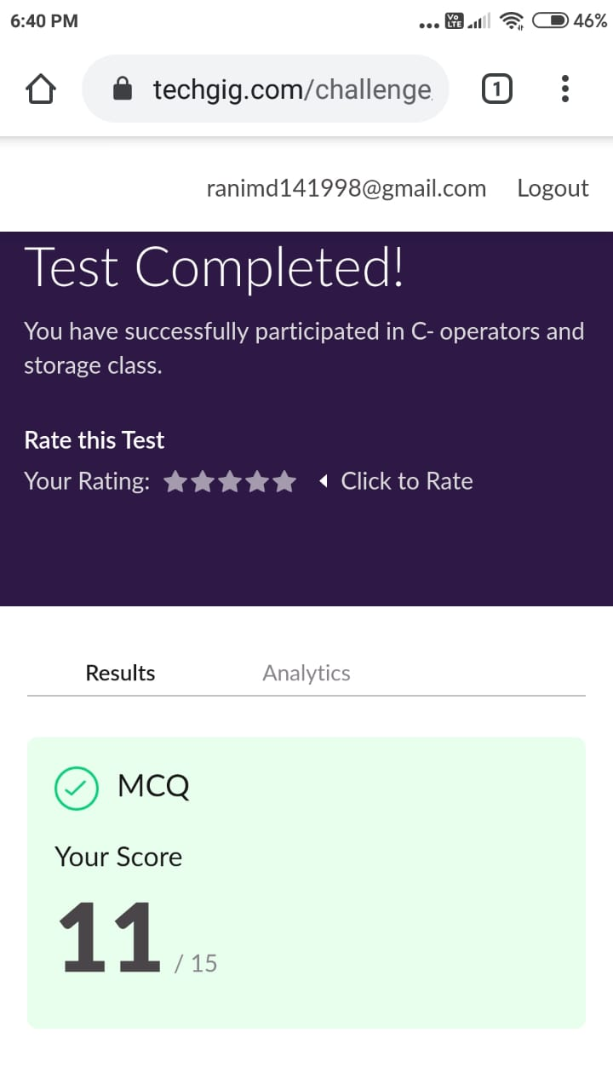

Online Course Details:

Attended class on the topic Programming in C. [from 9.20am to 10.45am]

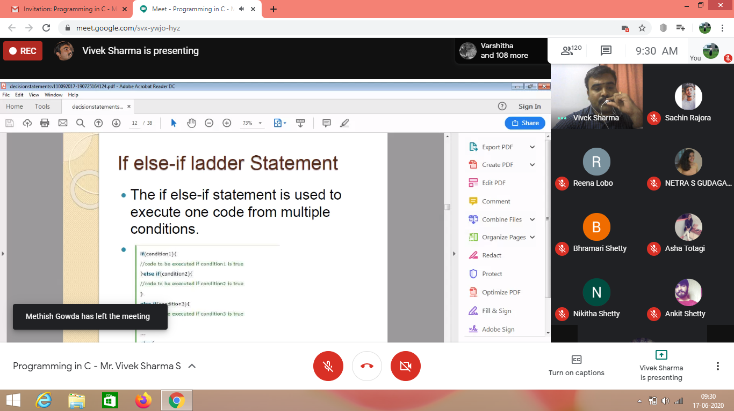

Attended Python Workshop on DA and ML. [from 10.45am to 01.40pm]

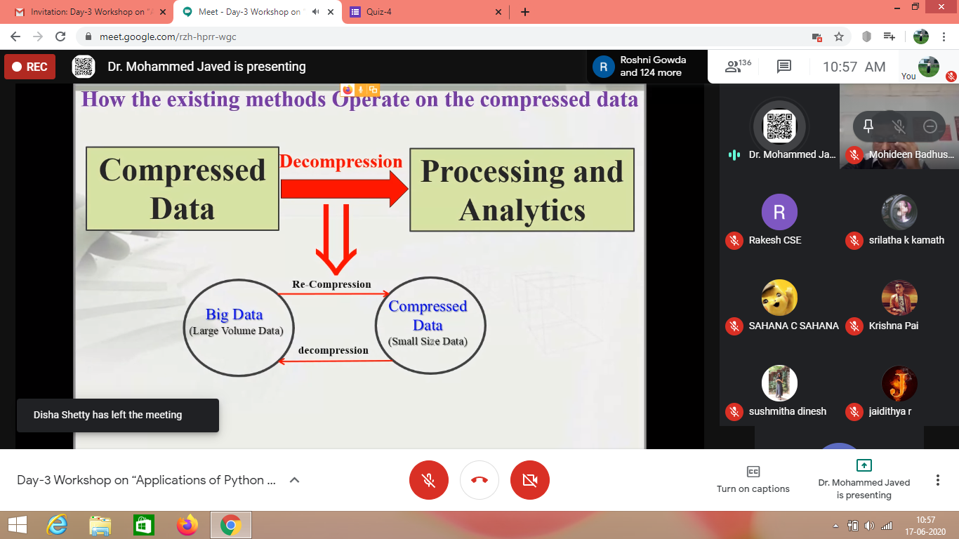

Online Coding Details: Python program to take in two strings and display the larger string without using built-in functions.

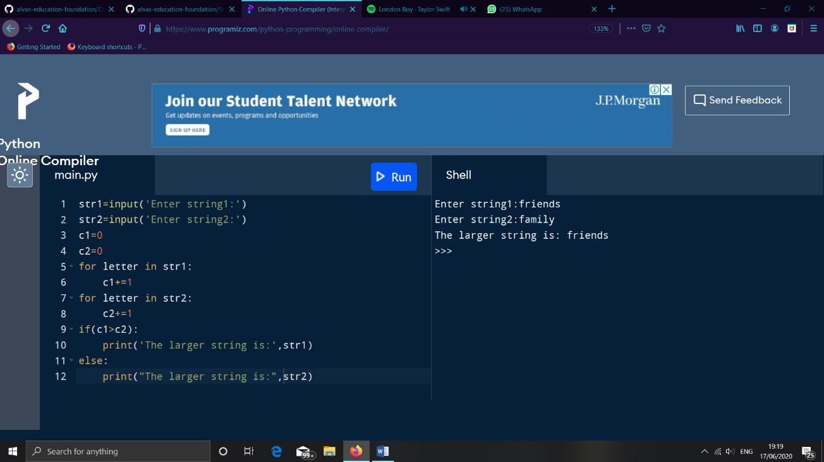

2 Java program to find the smallest positive integer value that cannot be represented as sum of any subset of a given array sorted in ascending order.

